EXPERIMENT 3
PROBABILITY DISTRIBUTIONS AND BAYES' THEOREM

Aim
To generate and visualize Bernoulli, Binomial, Poisson, Uniform, and Gaussian probability distributions using SciPy; calculate the probability that a patient has a disease after receiving a positive screening result using Bayes' theorem; simulate 100,000 patients to verify the theoretical probability empirically; and visualize how the posterior probability changes as disease prevalence varies, using NumPy, SciPy, and Matplotlib.

Problem Statement
A diagnostic centre uses a screening test for a disease. The disease prevalence is 1%, the test sensitivity is 95%, and the test specificity is 90%. The objective is to model standard probability distributions and determine the probability that a patient with a positive test result actually has the disease.
Parameter | Value
Disease prevalence | 1% (0.01)
Test sensitivity | 95% (0.95)
Test specificity | 90% (0.90)
False-positive rate | 10% (0.10)
Number of simulated patients | 100,000

Algorithm

Task 1: Generate and Plot Probability Distributions
- Start the program.
- Import NumPy, Matplotlib, and the required probability distributions from scipy.stats.
- Initialize the random seed using np.random.seed(42) to make the simulation reproducible.
- Set the sample size to 100,000.
- Generate Bernoulli samples using bernoulli.rvs() with probability of success p = 0.5.
- Generate Binomial samples using binom.rvs() with 20 trials and probability of success p = 0.4.
- Generate Poisson samples using poisson.rvs() with average rate lambda = 5.
- Generate Uniform samples using uniform.rvs() between 0 and 100.
- Generate Gaussian samples using norm.rvs() with mean 50 and standard deviation 10.
- Create subplots using plt.subplots().
- Plot the simulated samples as histograms and compare them with theoretical PMF or PDF values.
- Add titles, axis labels, legends, and adjust the layout using plt.tight_layout().
- Display the distribution graphs using plt.show().
- Stop.

Task 2: Calculate Probability Using Bayes' Theorem
- Start the program.
- Initialize disease prevalence as 0.01, sensitivity as 0.95, and specificity as 0.90.
- Calculate the probability of not having the disease: P(not D) = 1 - P(D).
- Calculate the false-positive rate: P(+ | not D) = 1 - specificity.
- Calculate the total probability of a positive test result using the law of total probability.
- Apply Bayes' theorem to calculate P(Disease | Positive).
- Display the prevalence, sensitivity, specificity, probability of a positive result, and posterior probability.
- Stop.

Task 3: Simulate 100,000 Patients and Verify the Result Empirically
- Start the program.
- Set the number of simulated patients to 100,000.
- Generate disease status for each patient using a Bernoulli distribution with prevalence 0.01.
- Represent disease present as 1 and disease absent as 0.
- Initialize an array to store each patient's test result.
- For patients with disease, generate test results using sensitivity 0.95.
- For patients without disease, generate test results using false-positive probability 0.10.
- Count true positives: patients who have the disease and receive a positive result.
- Count false positives: patients who do not have the disease but receive a positive result.
- Calculate the total number of positive test results.
- Calculate empirical probability as true positives divided by total positive results.
- Compare the empirical probability with the theoretical probability from Bayes' theorem.
- Display the simulation results and stop.

Task 4: Visualize Posterior Probability as Prevalence Changes
- Start the program.
- Generate prevalence values from 0.1% to 20% using np.linspace().
- Keep sensitivity at 0.95 and specificity at 0.90.
- Calculate the posterior probability for each prevalence value using Bayes' theorem.
- Store the posterior probabilities in an array.
- Create a figure using plt.figure().
- Plot prevalence against posterior probability using plt.plot().
- Mark the original prevalence of 1% using plt.scatter().
- Add the graph title, axis labels, grid, and legend.
- Adjust the layout using plt.tight_layout(), display the graph using plt.show(), and stop.

Theory and Formulae

Probability Distributions
Distribution | Description | SciPy function
Bernoulli | Models one trial with two outcomes: success (1) or failure (0). | bernoulli
Binomial | Models the number of successes in a fixed number of independent trials. | binom
Poisson | Models the number of events in a fixed interval, given an average rate. | poisson
Uniform | Models values with equal probability density over a specified interval. | uniform
Gaussian / Normal | A continuous, bell-shaped distribution described by mean and standard deviation. | norm

PMF (probability mass function) is used for discrete distributions such as Bernoulli, Binomial, and Poisson. PDF (probability density function) is used for continuous distributions such as Uniform and Gaussian.

Bayes' Theorem Calculation
Let D represent the event that a patient has the disease, and + represent a positive test result.
- P(D) = 0.01
- P(not D) = 1 - 0.01 = 0.99
- P(+ | D) = 0.95
- P(+ | not D) = 1 - 0.90 = 0.10
- P(+) = P(+ | D)P(D) + P(+ | not D)P(not D)
- P(+) = (0.95 × 0.01) + (0.10 × 0.99) = 0.1085
- P(D | +) = [P(+ | D) × P(D)] / P(+)
- P(D | +) = (0.95 × 0.01) / 0.1085 = 0.08756 ≈ 8.76%
Therefore, the probability that a patient actually has the disease given a positive screening result is approximately 8.76%.

Code
import numpy as np
import matplotlib.pyplot as plt
from scipy.stats import bernoulli, binom, poisson, uniform, norm
np.random.seed(42)
# ==========================================================
# TASK 1: GENERATE AND PLOT PROBABILITY DISTRIBUTIONS
# ==========================================================
SAMPLES = 100000
# 1. Bernoulli Distribution
p = 0.5
bernoulli_samples = bernoulli.rvs(p, size=SAMPLES)
# 2. Binomial Distribution
n = 20
p_binomial = 0.4
binomial_samples = binom.rvs(n, p_binomial, size=SAMPLES)
# 3. Poisson Distribution
lam = 5
poisson_samples = poisson.rvs(lam, size=SAMPLES)
# 4. Uniform Distribution
uniform_samples = uniform.rvs(loc=0, scale=100, size=SAMPLES)
# 5. Gaussian / Normal Distribution
mu = 50
sigma = 10
normal_samples = norm.rvs(loc=mu, scale=sigma, size=SAMPLES)
# Create subplots
fig, axes = plt.subplots(3, 2, figsize=(14, 15))
# Bernoulli
x = np.array([0, 1])
axes[0, 0].hist(
bernoulli_samples, bins=[-0.5, 0.5, 1.5],
density=True, alpha=0.6, label="Simulated"
)
axes[0, 0].plot(
x, bernoulli.pmf(x, p), "ro-", label="Theoretical PMF"
)
axes[0, 0].set_title("Bernoulli Distribution")
axes[0, 0].set_xlabel("Outcome")
axes[0, 0].set_ylabel("Probability")
axes[0, 0].legend()
# Binomial
x = np.arange(0, n + 1)
axes[0, 1].hist(
binomial_samples, bins=np.arange(-0.5, n + 1.5),
density=True, alpha=0.6, label="Simulated"
)
axes[0, 1].plot(
x, binom.pmf(x, n, p_binomial),
"ro-", label="Theoretical PMF"
)
axes[0, 1].set_title("Binomial Distribution")
axes[0, 1].set_xlabel("Number of Successes")
axes[0, 1].set_ylabel("Probability")
axes[0, 1].legend()
# Poisson
x = np.arange(0, 16)
axes[1, 0].hist(
poisson_samples, bins=np.arange(-0.5, 16.5),
density=True, alpha=0.6, label="Simulated"
)
axes[1, 0].plot(
x, poisson.pmf(x, lam), "ro-",
label="Theoretical PMF"
)
axes[1, 0].set_title("Poisson Distribution")
axes[1, 0].set_xlabel("Number of Events")
axes[1, 0].set_ylabel("Probability")
axes[1, 0].legend()
# Uniform
x = np.linspace(0, 100, 200)
axes[1, 1].hist(
uniform_samples, bins=50, density=True,
alpha=0.6, label="Simulated"
)
axes[1, 1].plot(
x, uniform.pdf(x, loc=0, scale=100),
"r-", label="Theoretical PDF"
)
axes[1, 1].set_title("Uniform Distribution")
axes[1, 1].set_xlabel("Value")
axes[1, 1].set_ylabel("Density")
axes[1, 1].legend()
# Gaussian
x = np.linspace(10, 90, 200)
axes[2, 0].hist(
normal_samples, bins=50, density=True,
alpha=0.6, label="Simulated"
)
axes[2, 0].plot(
x, norm.pdf(x, mu, sigma),
"r-", label="Theoretical PDF"
)
axes[2, 0].set_title("Gaussian / Normal Distribution")
axes[2, 0].set_xlabel("Value")
axes[2, 0].set_ylabel("Density")
axes[2, 0].legend()
fig.delaxes(axes[2, 1])
plt.tight_layout()
plt.show()
# ==========================================================
# TASK 2: BAYES' THEOREM
# ==========================================================
prevalence = 0.01
sensitivity = 0.95
specificity = 0.90
P_D = prevalence
P_not_D = 1 - prevalence
P_positive_given_D = sensitivity
P_positive_given_not_D = 1 - specificity
P_positive = (
P_positive_given_D * P_D
+ P_positive_given_not_D * P_not_D
)
bayes_probability = (
P_positive_given_D * P_D
) / P_positive
print("\\nTASK 2: BAYES' THEOREM")
print("Disease prevalence:", P_D)
print("Sensitivity:", sensitivity)
print("Specificity:", specificity)
print("Probability of positive result:", P_positive)
print(
"P(Disease | Positive):",
round(bayes_probability * 100, 2), "%"
)
# ==========================================================
# TASK 3: SIMULATE 100,000 PATIENTS
# ==========================================================
N = 100000
# 1 = Disease, 0 = No Disease
disease = bernoulli.rvs(prevalence, size=N)
# 1 = Positive, 0 = Negative
test_positive = np.zeros(N, dtype=int)
# Patients with disease
diseased_indices = disease == 1
test_positive[diseased_indices] = bernoulli.rvs(
sensitivity, size=np.sum(diseased_indices)
)
# Patients without disease
healthy_indices = disease == 0
test_positive[healthy_indices] = bernoulli.rvs(
1 - specificity, size=np.sum(healthy_indices)
)
true_positives = np.sum(
(disease == 1) & (test_positive == 1)
)
false_positives = np.sum(
(disease == 0) & (test_positive == 1)
)
total_positive = true_positives + false_positives
empirical_probability = true_positives / total_positive
print("\\nTASK 3: SIMULATION RESULTS")
print("Total patients:", N)
print("Patients with disease:", np.sum(disease))
print("True positives:", true_positives)
print("False positives:", false_positives)
print("Total positive results:", total_positive)
print(
"Empirical probability:",
round(empirical_probability * 100, 2), "%"
)
print(
"Theoretical probability:",
round(bayes_probability * 100, 2), "%"
)
# ==========================================================
# TASK 4: POSTERIOR PROBABILITY VS PREVALENCE
# ==========================================================
prevalence_values = np.linspace(0.001, 0.20, 200)
posterior_values = (
sensitivity * prevalence_values
) / (
sensitivity * prevalence_values
+ (1 - specificity) * (1 - prevalence_values)
)
plt.figure(figsize=(10, 6))
plt.plot(
prevalence_values * 100,
posterior_values * 100,
linewidth=2,
label="Posterior Probability"
)
plt.scatter(
[1], [bayes_probability * 100],
color="red", label="Original Prevalence (1%)"
)
plt.title("Posterior Probability vs Disease Prevalence")
plt.xlabel("Disease Prevalence (%)")
plt.ylabel("P(Disease | Positive) (%)")
plt.grid(True)
plt.legend()
plt.tight_layout()
plt.show()
print("\\nExperiment 3 Completed Successfully!")

Output
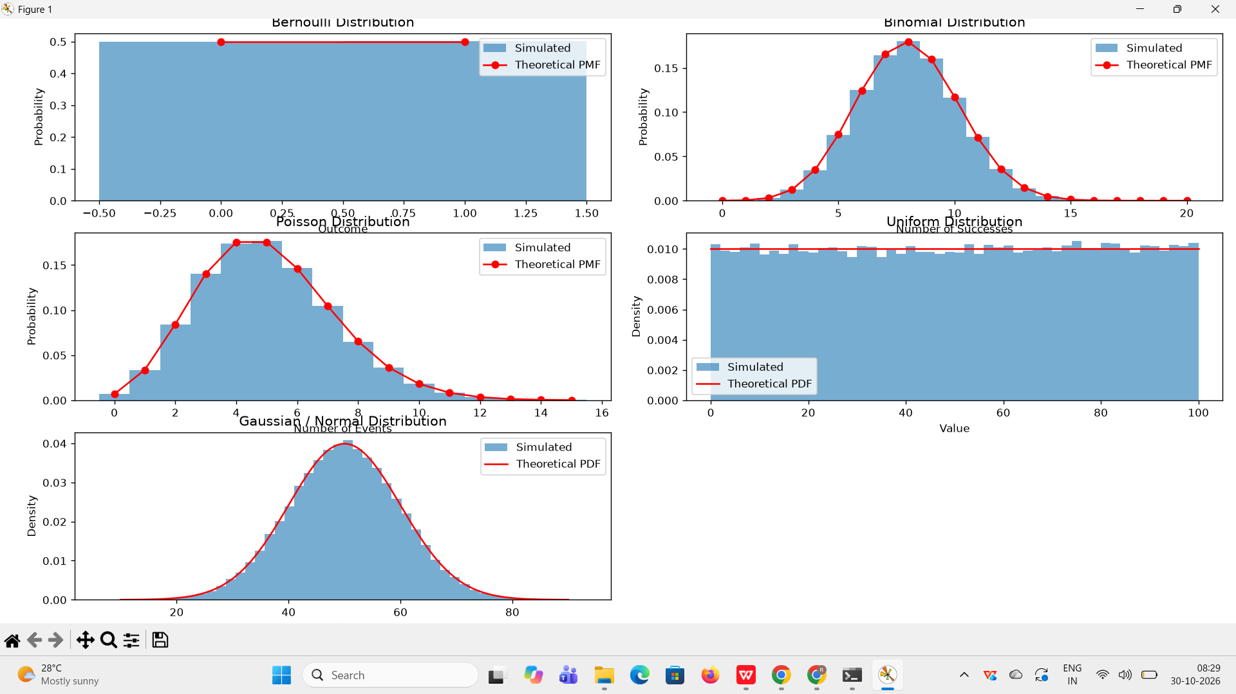

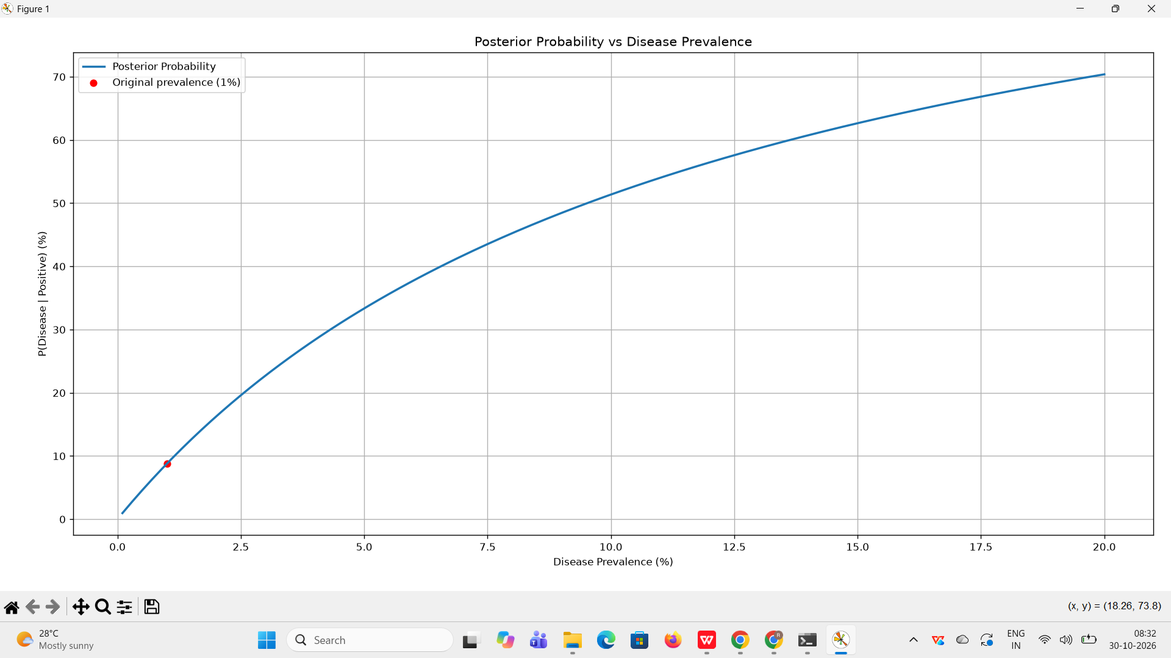
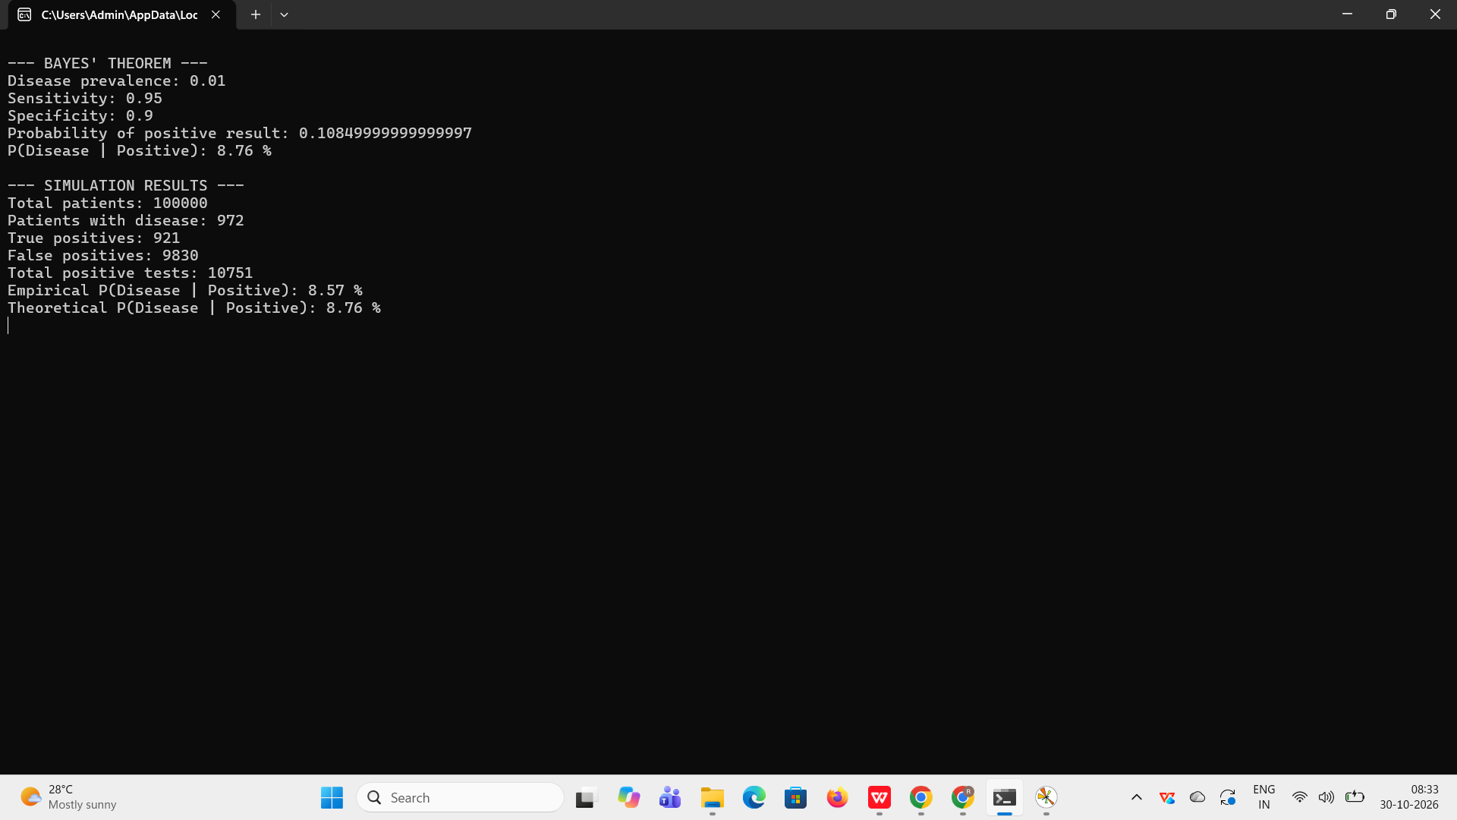

Result
Thus, Bernoulli, Binomial, Poisson, Uniform, and Gaussian probability distributions were successfully generated and visualized using SciPy and Matplotlib. Bayes' theorem was applied to calculate the probability that a patient has the disease after receiving a positive screening result. A simulation of 100,000 patients was performed to compare the empirical probability with the theoretical probability. Finally, the relationship between disease prevalence and posterior probability was visualized using Matplotlib. The theoretical probability of a patient having the disease given a positive test result was found to be approximately 8.76%.

